VOLVO PROJECT

Connection of loading contact for plug-in-hybrids
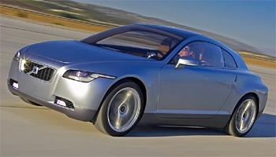

Al-Kattan Hayder, Boccacino Mickaël, Fraysse Alexandre, Mörsky Juho

April 2007
Table of contents

I. Introduction 3
A. Background 3
B. Requirements and limitations 3
C. Goal 3
D. Methodology 4
E. Project organization 4
F. Project scheduling 4
II. Organisation 5
A. Team organisation 5
B. Brainstormings 5
C. Mailing lists 5
D. Planning 5
III. Mechanical part 6
A. Different parts 6
B. The moving part 6
C. The door 7
D. The box 7
E. Material chosen, construction 7
F. Weight and volume 8
IV. Electrical part 9
A. Introduction 9
B. Power plug selection 9
C. Power converter selection 10
V. Automation parts and Interfaces 12
A. Introduction 12
B. Sensors choice 12
C. Interfaces 13
D. Manual part 13
VI. Conclusion 14

Introduction

Background

Volvo is a car manufacturer in Sweden. In the future they want to develop some electric hybrid vehicles that can load them from two different electric networks, the 230V and the 400V. As a part of these efforts, a sub-project is established with focus on Connection of loadings contact for plug-in-hybrids.

Requirements and limitations

The most important requirements for Volvo are low costs, low weight, low volume and easy to use.
But there is also some limitations from technical point of view on how to make the connection like:
- Various powers and thereby number of phases ( 230V and 400V)
- The connection can be galvanic or galvanically isolating
- The connection can be made manually
- The connection can be made partly automatically, the car is positioned close to a specially designed contact and maybe connected by some kind of robot.

The stakeholders in this project are:
- The future users of this hybrid car.
- Some contractors for spare parts including subsuppliers.
- The project has to respect international and Swedish laws and regulations.
- The project group

Goal

Specifications and other limitations
The first specifications in the project are:
- Various powers and thereby number of phases ( 230V and 400V)
- The connection can be galvanic or galvanically isolating
- The connection can be made manually
- The connection can be made partly automatically, the car is positioned close to a specially designed contact and maybe connected by some kind of robot.

Dissemination of results
The result of this project is a theoretical report with an oral presentation.

Methodology

The methodology to answer this task will be done by some brainstorming and some searching about the existing products. We have to speak also with Mats Alaküla and Hans Bangtsson to have some precision. We focus also on the management of the project to be on time for all the milestones. It is a part of the product developpement.

Project organization

They are four persons composing its project. Mörsky Juho has an electrical background and the others have a mechanical background. Boccacino Mickaël is also specialized in systems engineering.
The project manager in the team is Boccacino Mickaël. Juhohas done the electronical and electrical part, Alexandre has done the automation part, Hayder has done the mechanism of the door and Mickaël has done the moving part and the organisational part. The WBS is on the apendix to show the decomposition of the work.

Project scheduling

We have three very important milestones in this project.
- To send this report to present the project until the 26th of February
- To send an other report on the 20th of April, this is speaking about all our thinkings, the final solution with design and material choosen.
- The oral presentation from 7th to 9th of May with the final report. The presentation has a length of 15 minutes with 5 minutes more for questions.

Organisation

Team organisation

All the tasks had been centralised by the Project Manager in the team. Everybody has worked on his own way for their tasks. And all the decisions had been taken during brainstorming by agreement of all the members. We have choosen this way to take the decision in order to have a better harmony in the group.

Brainstormings

We have made many brainstorming to take the “good” decisions.
- The first brainstorming was there to split the tasks and to attribute the tasks to all the members. But we were only two of five in the first brainstorming so it wasn’t a good meeting. Because after that two people quitted the course of mechatronics. So we were only three in the project with Alexandre who has to make an internship in parallel.
- The second brainstorming was made in order to begin to give some ideas and to go forward by searching some existing products.
- The third brainstorming permit to introduce a new member in the team, Hayder Al-Kattan, to share all the ideas found and make the choice of the final design. After that, everybody has his work and has to begin his part of the project.
- The fourth brainstorming was a meeting to see the advancement of everybody and to see if all the interface are linked.

Mailing lists

We have used during all the job a mailing list. Everybody were inside the project and knew at everytime the advancement of everybody and can help or share his experience. It was very useful sometimes.

Planning

The planning for our project was simple. There was no multiple tasks to make. So we have followed a planning wich begin by the concept and initiation phase during three weeks because of problems with other teams members. And after we have done the developpement phasis during two more weeks and the design phasis during one week. Inside these three parts, there was some milestones with the first and second report and also some brainstorming to check if there was no problem in the developpement or in the design.

Mechanical part

Different parts

The mechanical part is composed with several components as you can see on the figure below:
- The moving part which serves to put the right plug in front of the door hole.
- One motor to move the moving part.
- The door that is the external hood on the car.
- One other motor to move automatically the door.
- A box in order to hide and store all the components inside.

The moving part

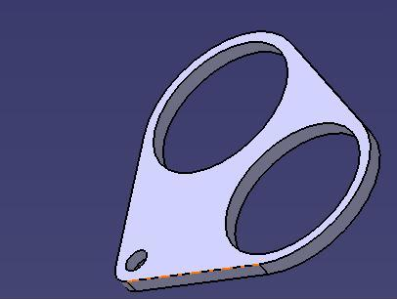
Figure 1: Moving part

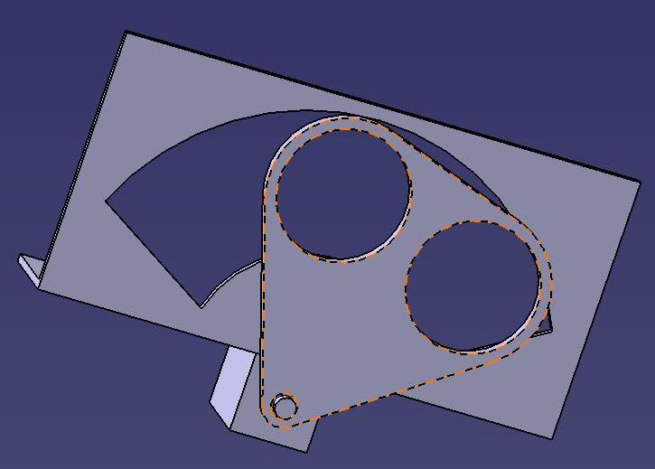
Figure 2: Moving part in position to plug

As you can see on the both figures above, the moving part is made with a sheet of plasts and three holes. The smallest is for the output of the motor and biggest are for the two plugs (two phasis and three phasis).
On the figure 2, there is a part of the assembly between the motor, the moving part and the box. Here is just a little part of the box in order to see how the mechanism is working. During the first step, the moving part is centered on the box. And after that the driver has made his choice for the number of phasis, the moving part turn on one side or in other side depending on the choice to get in the middle of the door. You have to imagine the box closed with just a door on the top.
The plug has to be centered to be in front of the door. So in order to have the best position, the motor move until the other plug touch the box and stop the moving. It is a kind of stop. We have choosen this kind of stop because it is very difficult to have a good position with an electric motor or if we want to use some specific motors, it is very expensive.

The door

The door is made like an other door for tank. We do not need a specific door. So if we have the same door, it is less expensive because the part is ever produced in series, the design still has been made by some designer.
But if we want a fully automated pluging, we need to make some modifications on the opening mechanism to get a motor that can control the opening and the closing of the door.

The box

The box has to contain all the mechanical parts, all the electronics components and to be the interface between the car and batteries and between the network and the car. This box has to be fixed on the car where the place and the accessibility is the best for the final user. It could be placed on the other side of the tank to have a simmetry on the car with the two door or on the trunk door.

Material chosen, construction

The chosen material to construct the holding part of the plug is the plastic. Its density is 1.1g/cm³. The plastic is chosen because it is an isolated material, light in weight, cheap, easy to mould & strong. It can be colored during construction simply by adding colors and it can also be painted after construction that it cannot be differentiated from metal (door).
The moving part of the 2 phase and the 3 phase plug is constructed by moulding a piece of plastic with three holes. The upper one is for the 2 phase plug and the lower one is for the 3 phase plug. The two holes have 50mm diameter each. The thickness of the plastic is 30mm. The plugs are screwed in the moving part.
The door is made like the others doorso we don’t care about this one.
The box is also made with plastics and can easily mould.

Weight and volume

Our system can be done with a lot of different configuration depending on where they want to install the pluging system. In fact we can separate the system in two little box. One for the mechanical which has 200*100*80 mm dimensions and one for the electronical spare parts with a dimension of 120 *80*50. We can put this in every configurations possible. We can reduce a bit these dimensions if it needed by using flat motors or others specifics components.

For the weight, we have estimated around 500 grammes for all the plastics parts, 120 grammes for each motors and 200 grammes for the electronics components. We have to had wire from the electronics components to the batteries, but we don’t know exactly the lenght of cable we need. So we can estimate the weight of the system between 1 kg and 1,5kg.

Electrical part

Introduction

There are two different supply voltages: 230V 50Hz 1-phase and 400V 50Hz 3-phase.
One of these is used at a time, and the voltage is to be converted to DC battery voltage. There are several battery packs connected in series and the total battery voltage is typically a few hundred volts. In the calculations we have assumed that it is 200 V. The traction motor is operated with that voltage. Furthermore, an auxiliary low voltage system (12 V) is needed to power all the other electric systems. The auxiliary voltage is usually created from the main battery using a DC-DC converter but it is beyond the scope of this project

Power plug selection

The charging connection can be made either galvanically or magnetically. Galvanic connection is a conductive coupling where the metal connectors of the car's charging plug are connected to the mains outlet using a cable that can provide sufficient power. Magnetic connection uses inductive coupling. A specially designed plastic paddle that includes a transformer primary and that is connected to the mains is inserted to a slot in the car that has the secondary coil. The magnetic circuit is thus completed without galvanic contact and energy is transferred in the magnetic field. The magnetic coupling has the advantage that it is very safe and it is practically impossible to get an electric shock. A drawback is that this system requires specific charging stations.

We wanted to make the system portable and as user-friendly as possible. The user should be able to charge the vehicle anywhere and not only in few places that have special equipment or special connectors. Therefore we opted for the conductive coupling which can be directly connected to the mains and only a cable is needed. The question is how to connect this cable to the vehicle. We could design a special plug to the car that fits the special socket in the cable. However we decided to use standardized spare plugs so that the user can use any off-the-shelf spare cable that has suitable IP protection class. This is a cheap solution that saves us some development effort. However Volvo might consider it as a drawback that they cannot sell specific expensive charging cables as spare parts.

The standard plugs and sockets are various in different market areas. In Sweden the common household standard for earthed plug is Schuko or CEE 7/4 which operates on 230 V 1-phase and supplies up to 16 A current. This can provide 3.7 kW charging power.
There is a lot more variation in 3-phase contacts (400 V). These are described in standard IEC 60309. Our choice is the quite common 32 A 3P+N+E connector which has five pins. It can provide charging power of 12.8 kW

Power converter selection

A converter is needed to transfer the power from mains (AC) to battery (constant DC).

As in all power electronics, the efficiency of the power converter should be high (>95 %) to avoid excessive thermal losses. The converter must have sufficient heat sinks to dissipate the energy from conduction and switching losses.

Linear electronics is out of the question because of bad efficiency. The simplest power electronic solution would be line-commutated diode converter with a transformer. It needs no control electronics, but the quality of output voltage and input current is very bad albeit they are somewhat better in the 3-phase case. Using thyristor bridge instead of diodes would require simple control but it would not improve the quality very much.

Therefore the best option is to use a switch-mode power supply (SMPS) where the input DC voltage is chopped to high frequency AC. The advantage of SMPS is that the transformer (if applicable) can be small because of the high frequency.

Regular step-down (buck) converter provides no galvanic isolation. The same goes for Cúk converter. 2- or 4-quadrant converters would be excessive for this application where the power is flowing only in one direction and thus we need only operation in one quadrant.

It is reasonable to use a converter with a transformer to change the input voltage to a more convenient level. Moreover it provides a galvanic separation between supply and load which may reduce interference. Some of the possible topologies are flyback, forward and push-pull converters.

For simplicity the converter of our choice is a flyback converter. It is a switch-mode power supply based on the buck-boost topology but equipped with a transformer that can change the voltage level and provides galvanic isolation between input and output. The magnetic circuit operates also as energy storage. It can have two primary coils whose number of winding turns can be adjusted for each of the supply voltages. The secondary coil that is connected to the output can be common for both. (See figure 3).

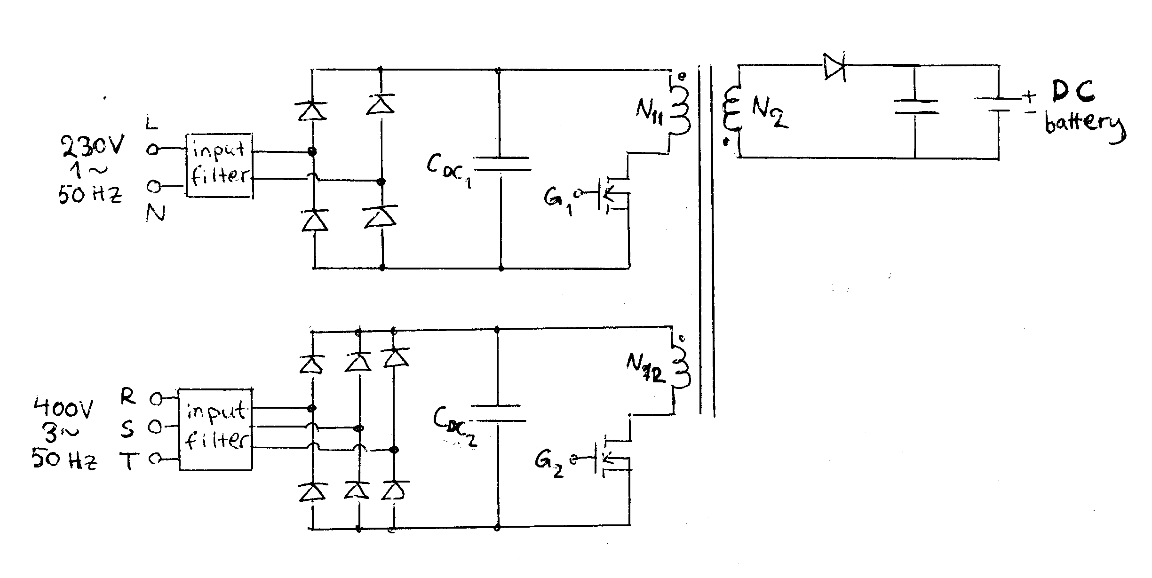
Figure 3: The principle of the charging circuit

Flyback is a DC-DC converter and therefore the line voltage needs to be rectified. This is done by using diode bridges after line filters. The diode bridges are followed by DC link capacitors C_{DC1} and C_{DC2}. They are charged to the peak value of the input voltage, i.e. $\sqrt{2}⋅\text{230}V=\text{325}V$ and $\sqrt{2}⋅\text{400}V=\text{566}V$ respectively.

The ratio of output and input voltages of a flyback converter during continuous conduction mode is [1]
$\frac{V_{\text{out}}}{V_{\text{in}}}=\frac{N_{2}}{N_{1}}\frac{D}{1−D}$,
where D is the duty cycle of the pulse-width modulated switch transistor and N₂ and N₁ are the numbers of turns in secondary and primary coils respectively.

If we choose the set point of duty cycle D = 0.5 then V_{out}/V_{in} = N₂/N₁ and we get the following transformer ratios:
N₁₁/N₂ = 325/200 = 1.63
N₁₂/N₂ = 566/200 = 2.83

If we instead use 1:1 transformer the duty cycles would be 0.38 and 0.26 respectively.
This can be easily adjusted according to the actual voltage.

The output voltage is stabilized with a separate control circuitry that controls the gate of the switch transistor (G₁ and G₂) thus adjusting the duty cycle to variations in input voltage. The output voltage is measured and provided through a feedback loop to the controller. The feedback loop must also have galvanic isolation.

Moreover, snubbers are needed to protect the components from excessive voltages during switching transients.

Automation parts and Interfaces

Introduction

The product needs to provide two operating modes. The first one should be a fully automatic plug-in from the station to the car. Using this mode, the driver could only need to press a button inside the car to begin the loading once the car is parked next to the station. The second mode is a manual plug-in, to be able to reload the batteries even when we do not have any energy left to use the automatic mode, or when this one has a malfunction.
One of the main issue of this task is to detect the position of the vehicle compared to the station, this way the robot placed on the station can reach the plug on the car. A kind of radio communication may also be needed to transmit these data (number of phasis, time to fill the battery, ...) between the robot and the system on the car.

Sensors choice

We need to measure the three dimensions (x,y and z), but we cannot assume that the car will be perfectly parallel to the station, we also need to know the slope of the car compared to the station. So we can have two laser sensors (with an angle between each other) to measure the distance in the z direction and the slope of the car. Then we can use an optical sensor to read some figures placed on the station to get the position in x and y.
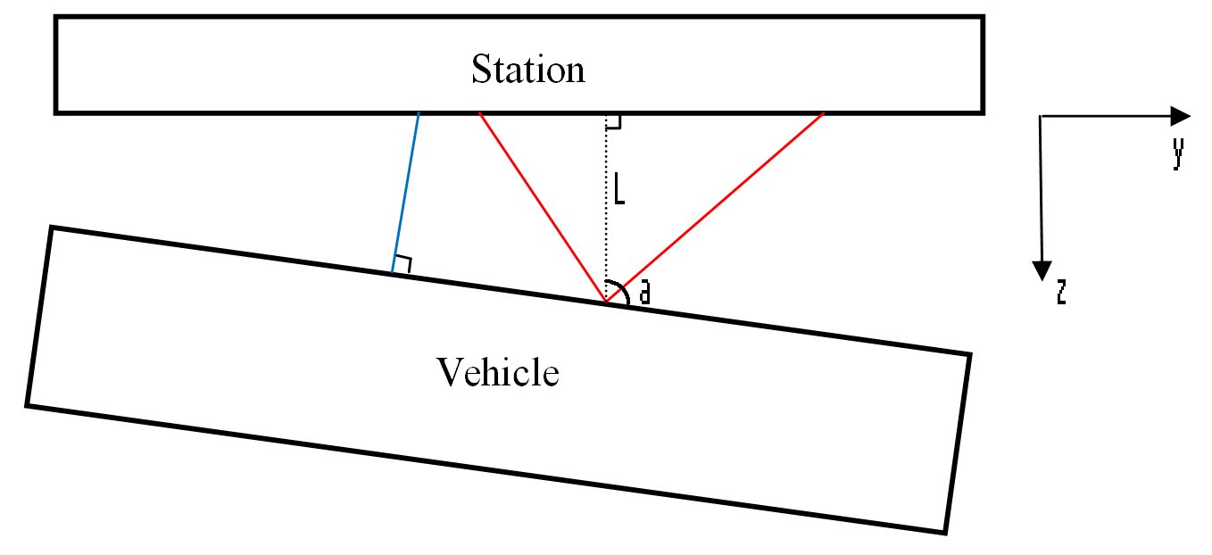

Laser sensors, which measure the length L and the angle a
Optical sensor, which measure the x and y position

On this sketch, we can see the influence of the angle a on the value read by the optical sensor. Because this sensor actually read the figure place in front of it, and this is a problem when the car is not perfectly parallel to the station.

Interfaces

On this system it is quite easy to figure out where and how are designed the interfaces between the mechanical and the electrical elements. These interfaces are constituted by the two different plugs which provide a mechanical support for the electrical transport via the coupling male/female plugs.

Electrical
part
Mechanical part
Plugs

Another example of interconnection between these two fields is the cooling of the electrical components. The different energy convertors inside the system produce a quite important heating that we can handle with a mechanical approach like the drilling of few cooling holes in the housing, with a fan if necessary.

Manual part

The system must allow the loading of the vehicle with an entire manually mode. The simplest way to provide this mode is to be able to disconnect the motors on the system. This way they will not resist to a manual action to move the different parts such as the plugs. There are two possibilities. The software one is to make sure that the feeding of these motors will be stopped if we reach certain conditions (errors, user order…) this should actually be the default behavior of the system. The user can manipulate the moving part and the door if the mechanism is not in automatic mode. He can do himself the coupling of the plug if he wants.

Conclusion

In the future, we will need to use others energies to preserve the ressources in petrol and decrease the useability price of cars. One of the solution is to have an hybrid car. We have made in this project an example of plugging system to connect the electricity network to the car batteries. To integrate this system in any Volvo cars we need only a free volume of around 2 liters. This system will increase the weight of less than 1,5kg and is very cheap. The use of plastics has contributed to the light weight and the cheap price. The system can be integrated everywhere Volvo wants. The external door contributes to the design of the car with the same colour .
It exists also others advantages in our solutions because the filling of the batteries can be done manually or fully automateic. So Volvo can integrate a manually filling for the bottom of the range with an option to get it automatic and integrate a fully automatic for the top of the range. The Automatic filling can be standard for all the car brand if Volvo imposed it on the market.

The system can be integrated everywhere Volvo wants. The external door contributes to the design of the car with the same colour .
Reference:

[1] Kyyrä J., Hakkuriteholähteet-kurssin luentokalvot,
http://users.tkk.fi/%7Ejkyyra/hakkuriteholahteet/galvaanisesti_erotetut.pdf ,
Helsinki University of Technology, 2007.

